Open Mapix software. It is recommended to perform Mapix file opening and analysis in the computer operating the InnoScan 710 AL because it harbors a Xeon processor.
Open the image that you wish to quantify dots from; you are opening huge files, wait a few seconds after each click, do NOT click more than once.
Import a grid from a GAL file:
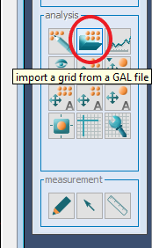

This GAL file must be the one downloaded from LIBRA, not the one generated by the Aushon arrayer. Choose the GAL file for the corresponding slide scanned image (i.e. same slide barcode). Mapix will yield something like this, shown below:
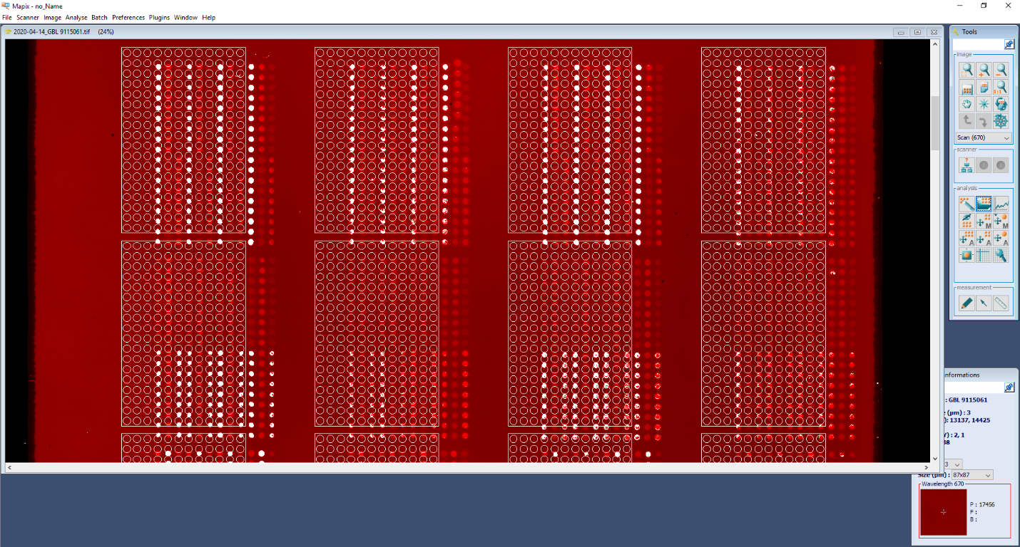

Click on ” find all automatically”; you are dealing with huge files, wait a few seconds after each click, do NOT click more than once:
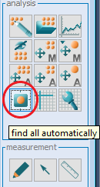

Mapix will yield something like this, shown below:
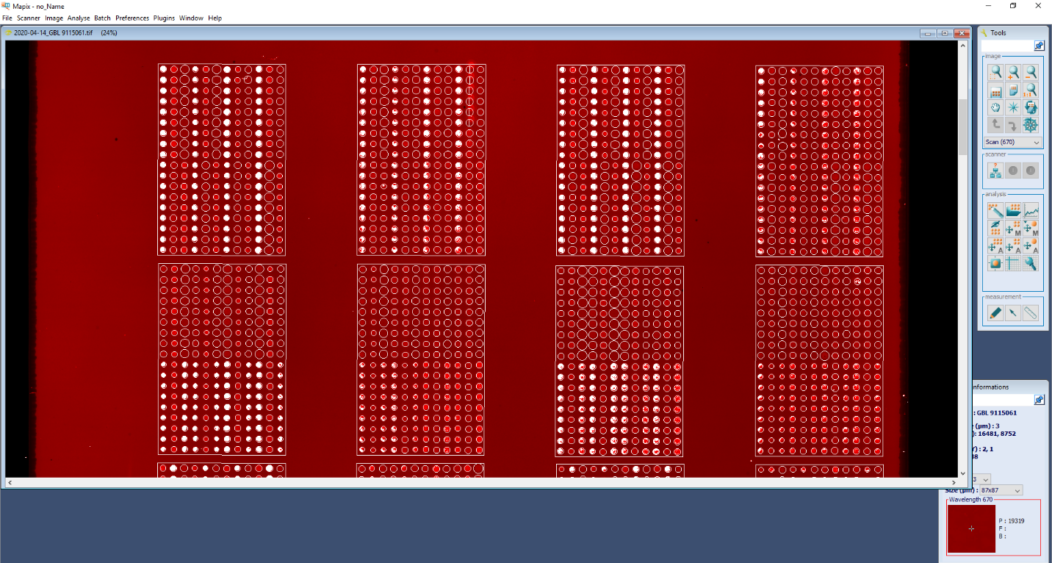

Click on “block modification”;
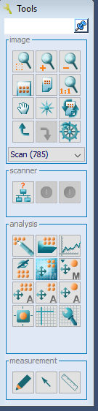
Select block; move block to desired position. Then, click on “spot modification”;

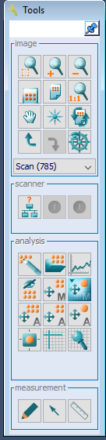
Select spot and move to desired position.

Click on “quantification process”; you are dealing with huge files, wait a few seconds after each click, do NOT click more than once:
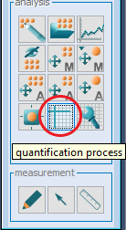

Mapix will yield something like this, shown below:
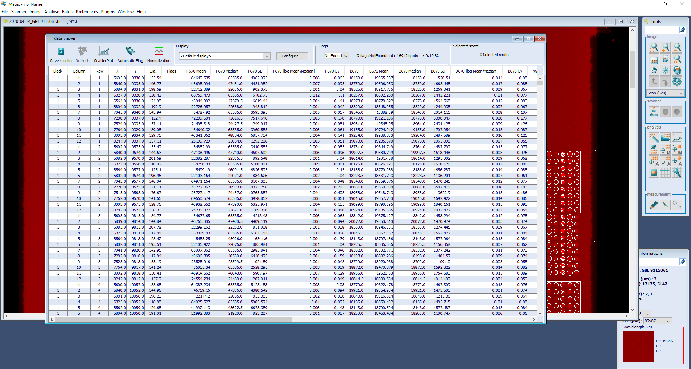

Click on “Save results”; you are dealing with huge files, wait a few seconds after each click, do NOT click more than once. Save using the recommended filename with the *.gpr extension.
Upload the *.gpr file to LIBRA (Slides -> Import analysis from GPR).

